**A Stage-structured Individual-based**

**Model for Ecological and Evolutionary**

**Dynamics of** *Drosophila melanogaster*

**Populations Adapted for Larval Crowding**

**Sayyed Imran Rashid**

*A dissertation submitted for the partial fulfilment of*

*BS-MS dual degree in Science*



**Indian Institute of Science Education and Research, Mohali**

**April 2020**

# List of Figures

|  |  |
| --- | --- |
| 1.1 Ecological dynamics in a vial during larval feeding . . . . . . . . . . . | 2 |
| 1.2 Flowchart of the larval stage in the model . . . . . . . . . . . . . . . | 3 |
| 1.3 Waste build-up in the feeding band . . . . . . . . . . . . . . . . . . . | 5 |
| 1.4 Change in the food quality of feeding band . . . . . . . . . . . . . . . | 6 |
| 2.1 Effect of initial feeding rate and efficiency on body size . . . . . . . . | 9 |
| 2.2 Effect of initial feeding rate and efficiency on development time . . . | 10 |
| 2.3 Effect of initial feeding rate and efficiency on survivorship . . . . . . . | 10 |
| 2.4 Effect of initial feeding rate and efficiency on final feeding rate . . . . | 10 |
| 2.5 Effect of initial feeding rate and critical size on body size . . . . . . . | 11 |
| 2.6 Effect of initial feeding rate and critical size on development time . . | 12 |
| 2.7 Effect of initial feeding rate and critical size on survivorship . . . . . | 12 |
| 2.8 Effect of initial feeding rate and critical size on final feeding rate . . . | 12 |
| 2.9 Effect of critical size and efficiency on body size . . . . . . . . . . . . | 13 |
| 2.10 Effect of critical size and efficiency on development time . . . . . . . | 14 |
| 2.11 Effect of critical size and efficiency on survivorship . . . . . . . . . . . | 14 |
| 2.12 Effect of critical size and efficiency on final feeding rate . . . . . . . . | 14 |
| 3.1 Model flowchart . . . . . . . . . . . . . . . . . . . . . . . . . . . . . . | 17 |
| 3.2 Timeseries for initial feeding rate . . . . . . . . . . . . . . . . . . . . | 18 |
| 3.3 Timeseries for efficiency . . . . . . . . . . . . . . . . . . . . . . . . . | 19 |
| 3.4 Timeseries for critical size . . . . . . . . . . . . . . . . . . . . . . . . | 19 |
| 3.5 Timeseries for waste tolerance . . . . . . . . . . . . . . . . . . . . . .  3.6 Effect of initial variation in initial feeding rate and efficiency on mean | 20 |
| trait values at generation 50. . . . . . . . . . . . . . . . . . . . . . . . | 21 |

3.7 Effect of initial variation in initial feeding rate and critical size on mean

|  |  |
| --- | --- |
| trait values at generation 50. . . . . . . . . . . . . . . . . . . . . . . .  3.8 Effect of initial variation in critical size and efficiency on mean trait | 22 |
| values at generation 50. . . . . . . . . . . . . . . . . . . . . . . . . . .  3.9 Effect of heritability in initial feeding rate and efficiency on mean trait | 23 |
| values at generation 50. . . . . . . . . . . . . . . . . . . . . . . . . . .  3.10 Effect of heritability in initial feeding rate and critical size on mean | 24 |
| trait values at generation 50. . . . . . . . . . . . . . . . . . . . . . . .  3.11 Effect of heritability in critical size and efficiency on mean trait values | 25 |
| at generation 50. . . . . . . . . . . . . . . . . . . . . . . . . . . . . . | 26 |

ii

# List of Tables

B.1 Distributions and values of larval trait parameters used for initiating

the model . . . . . . . . . . . . . . . . . . . . . . . . . . . . . . . . . 29

B.2 Values of scaling parameters used in the model . . . . . . . . . . . . . 29

B.3 Values of larval parameters used for initiating the model . . . . . . . 30

# Contents

1. **Modelling Larval Stage in a Vial 1**
   1. Ecology of a Vial in Drosophila Cultures . . . . . . . . . . . . . . . . 1
   2. Larval Stage Model . . . . . . . . . . . . . . . . . . . . . . . . . . . . 2
   3. Simulations for Feeding Band Dynamics . . . . . . . . . . . . . . . . 5
      1. Waste build-up dynamics results . . . . . . . . . . . . . . . . . 5
      2. Food quality dynamics results . . . . . . . . . . . . . . . . . . 6
2. **Interplay between Larval Trait Parameters 8**
   1. Initial Feeding Rate and Efficiency . . . . . . . . . . . . . . . . . . . 9
   2. Initial Feeding Rate and Critical Size . . . . . . . . . . . . . . . . . . 11
   3. Critical Size and Efficiency . . . . . . . . . . . . . . . . . . . . . . . . 13
3. **Modelling Evolution of Life-history Traits 15**
   1. Modelling Adult Stage . . . . . . . . . . . . . . . . . . . . . . . . . . 15
      1. Pupal stage . . . . . . . . . . . . . . . . . . . . . . . . . . . . 15
      2. Fecundity . . . . . . . . . . . . . . . . . . . . . . . . . . . . . 16
      3. Inheritance . . . . . . . . . . . . . . . . . . . . . . . . . . . . 16
   2. Effect of Laral Crowding on the Evolution of Life-history Traits . . . 18
   3. Effects of Variation on the Evolution of Larval Trait Parameters . . . 20
      1. Variation in the Initial Distribution of Larval Trait Parameters 20
      2. Heritability of Mid-parent Value . . . . . . . . . . . . . . . . . 24

**References 27**

1. **Code 28**

iv

1. **Tables 29**
   1. Larval Trait Parameters . . . . . . . . . . . . . . . . . . . . . . . . . 29
   2. Scaling Parameters . . . . . . . . . . . . . . . . . . . . . . . . . . . . 29
   3. Other Larval Parameters . . . . . . . . . . . . . . . . . . . . . . . . . 30

**Chapter 1**

# Modelling Larval Stage in a Vial

Competition for food during the larval stage is determined by not only larval density but also ecological factors inside a food vial such as nitrogenous waste build-up (ref), diffusion of waste in the food below (ref), total food amount (ref). Thus, in order to investigate the adaptation to larval crowding, it is crucial to understand the ecology of a vial in which the larval stage of Drosophila lab populations is maintained and replicating such environment during larval feeding becomes the first step in modelling the larval growth. Previous experimental studies on Drosophila in laboratory conditions have shown the pattern of the growth of larvae, excretion of nitrogenous waste, larval feeding behaviour in response to the waste excreted, development time (ref). Based on these experimental studies, I have created an individual-based model which considers larval trait parameters such as - feeding rate, efficiency to convert food into biomass, critical size and waste tolerance, to measure other traits like larval body size, development time, and survivorship.

## 1.1 Ecology of a Vial in Drosophila Cultures

During larval feeding inside a vial, larvae can access only a certain amount of food from the total food available at a given time point. This is due to their inability to dig more to access food (ref), and this accessible part of the food is referred as the feeding band. For simplicity, feeding band is taken as volume of food proportional to the width of the vial. In the model, I also assume this feeding band to be a constant volume of food in all types of culture vials till it reaches the bottom of the vial. The growth of larvae in the model is affected by waste build up and food quality in the feedin band. I also consider a diffusion band which is a part of the total food below feeding band where some amount of waste can diffuse from feeding band at each time step. Fig 1.1 is the visualization of feeding band and diffusion band during larval

feeding.

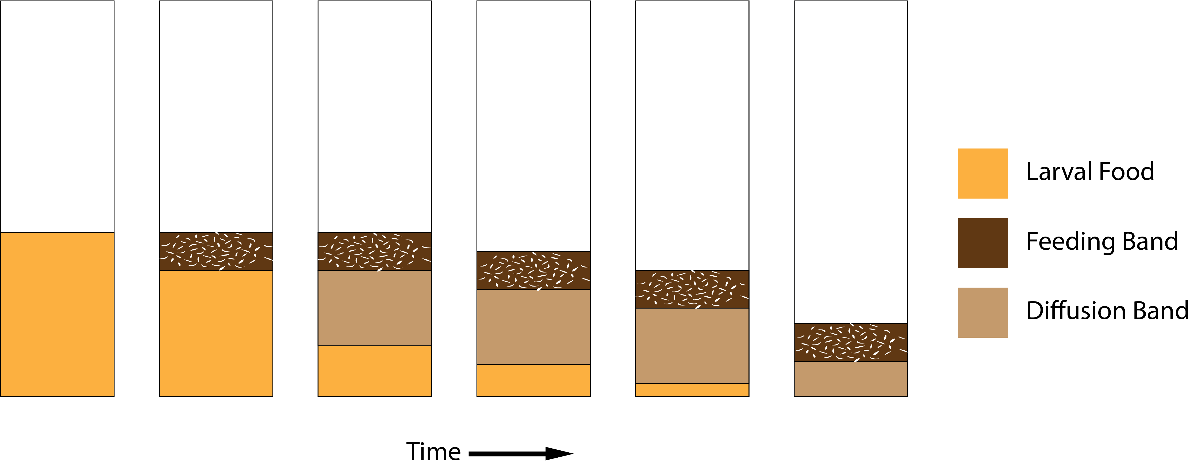

Figure 1.1: Ecological dynamics in a vial during larval feeding

## 1.2 Larval Stage Model

Each individual egg is assigned larval trait parameters from respective distributions with certain mean and variation given in table B.1. For a given amount of food and number of eggs, the model follows certain set of rules as described in fig 1.2 which are simulated in discrete time steps. The sex ratio within eggs is kept 1:1. Critical size and efficiency are taken as sexually dimorphic traits and are assigned depending on the sex of the individual larva. Critical size and efficiency of females are assumed to be 20% higher than that of males, so that females attain higher body size in the same time period as males but survivorship between sexes is same. (ref)

The inital size of all larvae is same and the growth is determined by larval trait parameters such as initial feeding rate, efficiency, waste tolerance and critical size. The larval growth is divided into two stages determined by whether critical size is reached or not, These stages are called pre-critical and post-critical stage.

In pre-critical stage of the larva, feeding rate is a linear function of time, given as:

*Fri*(*t*) = *fri* + *x*1 · *t*

Here, *fri*: initial feeding rate of *ith* larva; *x*1: scaling parameter, *t*: given time step; *Fri*(*t*): Feeding rate at time *t*

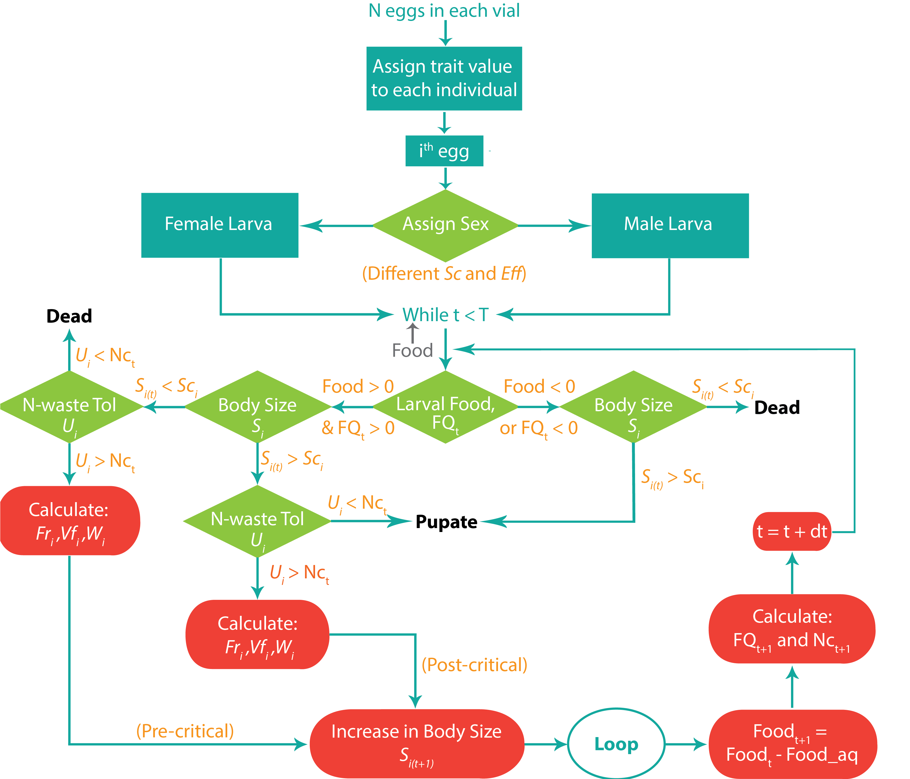

Figure 1.2: Flowchart of the larval stage in the model

Feeding rate stays constant During post-critical stage. During pre-critical growth Volume of food taken in one bite is taken as constant *Vf*(*pre*) and during post-critical growth it is *Vf*(*post*) = 1*.*5 · *Vf*(*pre*). Food consumed by all larvae at time step *t* is given as:



The increase in body size at time *t* is *Si*(*t* + 1) and give as:



Here,

*i*: Efficiency to convert food eaten into biomass of *ith* larvae,

*FQfb*(*t*): Food quality of the feeding band at time *t*

After feeding and utilizing food consumed at given time step, larva produces nitrogenous waste *waste prodi*(*t*). This affects the total waste produced by all the larvae

after feeding:



Based on this waste produced, total waste accumulated till time step *t* in feeding band and diffusion band is calculated considering *kd* proportion of waste in the feeding band diffuses into diffusion band at each time step.

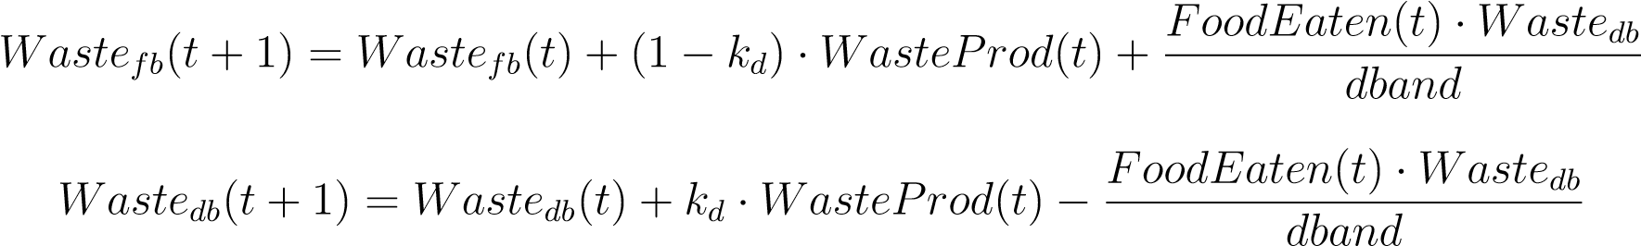

Food quality of the feeding band at time step *t* is:

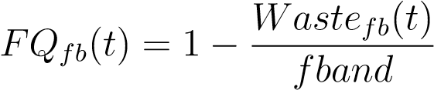

If *FQfb*(*t*) ≤ 0, it means that there is no food available to eat and feeding band contains only nitrogenous waste and larvae stop eating.

*kd* is dependent on the food available in the vial and determines whether waste is diffused into the diffusion band. Its values are assigned at each time step as follows:

i *kd* is a constant *>* 0 ... if *food >* (*fband* + *dband*) ii *kd* = 0 ... if *food* ≤ (*fband* + *dband*)

Each larva feeds and increase the body size in each time step based on the conditions for food available (*food*), food quality (*FQ*(*t*)), critical size (*sci*) and waste tolerance (*ui*) described in fig 1.2.

Values for all parameters used in the larval stage of the model, are given in table B.1, table B.2 and table B.3. These values were obtianed by calibrating survivorship, body size and development time results similar to the empirical results in various larval densities Sarangi, 2018.

## 1.3 Simulations for Feeding Band Dynamics

Simulations are performed for trait values in table B.1 to observe the waste build up dynamics and food quality decrease in a food vial with different larval densities during larval feeding.

### 1.3.1 Waste build-up dynamics results

In fig 1.3, waste build in the feeding band throughout larval feeding at different larval densities is plotted. At low density i.e. 60 eggs / 6 ml food (MB culture), there is very little nitrogenous waste building up due to diffusion and plenty of food available below the feeding band at all time steps.

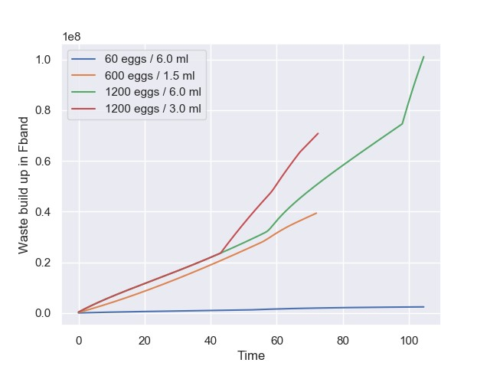

Figure 1.3: Waste build-up in the feeding band

High densities of 600 eggs / 1.5 ml food (MCU culture) and 1200 eggs / 3 ml food (CCU culture) show different patterns of waste build up in the feeding band, even though total larval density is equal. In MCU culture vial, there is very little food available below the feeding band, thus diffusion does not occur and waste build in the feeding band increases gradually. In CCU culture vial, waste build-up is almost in same qauntity as in MCU culture in earlier stage, even though effective larval density is double (number of larvae per feeding band). This is due to the availablilty of food below feeding band in CCU culture where waste can diffuse. After approx. 40*th* time step, diffusion stops and waste from diffusion band enters feeding band in more quantity, thus giving a sudden increase in the waste build rate.

LCU culture vial (1200 eggs in 6 ml food) also shows pattern of waste build in the feeding band similar to CCU culture vial, but shows increase in the rate of waste build up approx. after 60*th* time step. This is due to the food is still available below the feeding band. At approx. 100*th* time step in LCU culture vial shows even more increase in the rate of waste build because diffusion band touches the bottom and

starts shrinking.

### 1.3.2 Food quality dynamics results

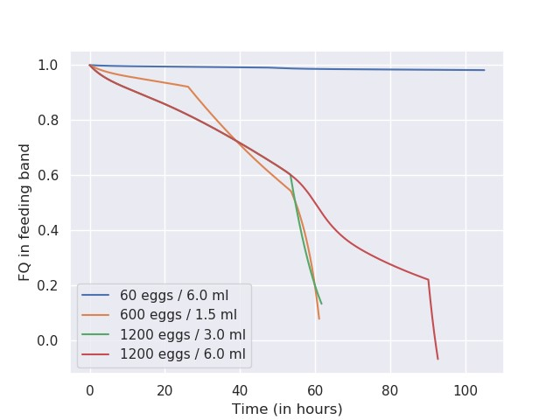

Figure 1.4: Change in the food quality of feeding band

Fig 1.4 shows the decrease in the quality of the food present in the feeding band. Food quality being negatively correlated with the amount of waste build-up in the feeding band, it shows patterns similar to waste build-up during larval growth in all crowding condtions. Since food quality affects body size increment at each time step. Body size increment between 40*th* and 60*th* time step is completely different in MCU and CCU cultures even though there larval density is equal. In LCU culture, decrease in food quality is simlar to CCU culture till 60*th* time step but later decreases gradually unlike CCU. This gradual decrease is due to gradual waste diffusion into the available food below the feeding and diffusion band. Once diffusion band hits the bottom at

90*th* time step, food quality decreases rapidly.

**Chapter 2**

**Interplay between Larval Trait**

# Parameters

In the larval stage model, trait parameters used are initial feeding rate, efficiency, critical size and waste tolerance. These parameters can not be measured directly via experimental approaches, but their effects on other larval traits such as body size, feeding rate at the third instar, development time can be measured easily. Here, I explore how larval trait parameters interact with each other and affect body size, time to reach critical size, feeding rate at critical size and survivorship. Since feeding rate in the model stays constant after reaching critical size, it can be taken as proxy for feeding rate at the third instar stage. Also, time to reach critical size is taken as a proxy for development time since time period between critical size and pupation is taken as a constant in all densities (ref). Larval stage is simulated to obtain body size, development time, final feeding rate (at critical size) and survivorship in MB, MCU and CCU cultures for each combination of initial feeding rate, efficiency and critical size from respective range of mean trait values. Here, effect of waste tolerance is ignored since no significant effect was observed on the body size, development time, final feeding rate and survivorship. Using experimental data and these simualtion results, best combination of trait values are obtained which represents ancestral trait values for each population. Traits measured using these trait values represent MB flies from the experimental data and these trait values are used in further simulations.

## 2.1 Initial Feeding Rate and Efficiency

All simulation results show that the larval body size, development time, final feeding rate and survivorship are dependent on the larval density. In MCU and CCU culture, overall body size and survivorship are lesser while development time and final feeding rate are always higher for the same range of trait values than in MB culture (see fig 2.1 - fig 2.12). The larval body size is positively correlated with both initial feeding rate and efficiency at low density (MB culture), while at high densities (MCU and CCU cultures) it is positively correlated only with efficiency (see fig 2.1). In MCU culture, body size is not affected by the initial feeding rate unlike in CCU culture where initial feeding rate gives lesser body size. Fig 2.2 shows a negative correlation of development time i.e. time to reach critical size with both inital feeding rate and efficiency at all larval densities. survivorship is logistically dependent on efficiency only in MCU and CCU cultures (see fig 2.3). In MCU culture, survivorship does not show any dependence on inital feeding rate, but in CCU culture it shows a slight negative correlation with initial feeding rate. At all larval densities, final feeding rate is positively correlated with inital feeding rate and negatively with efficiency (see fig 2.4). In MCU and CCU culture, final feeding rate show exponential dependence with efficiency which increases more with higher initial feeding rate.

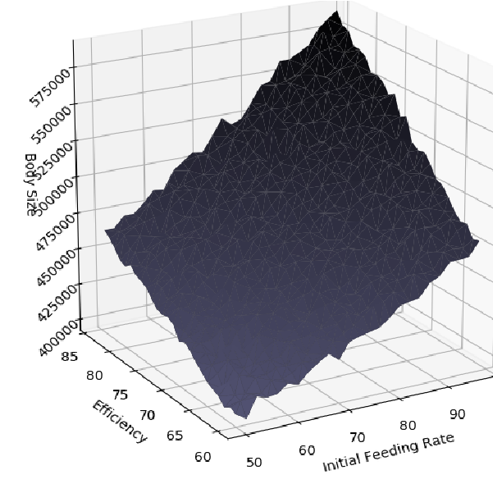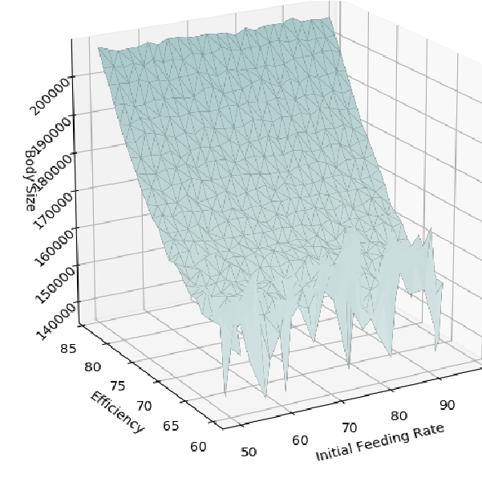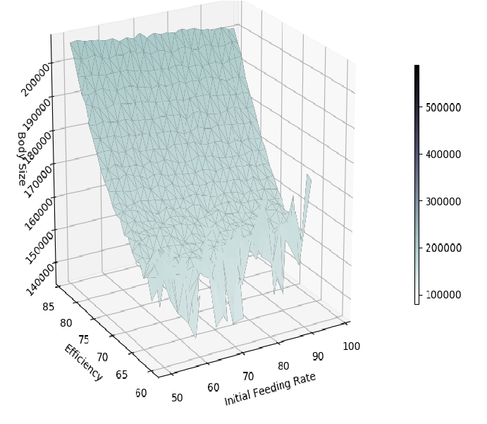

(a) MB culture (b) MCU culture (c) CCU culture

Figure 2.1: Effect of initial feeding rate and efficiency on body size

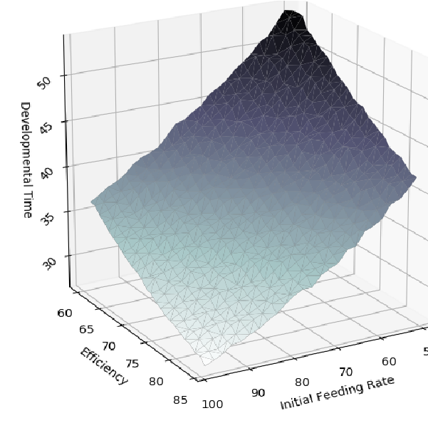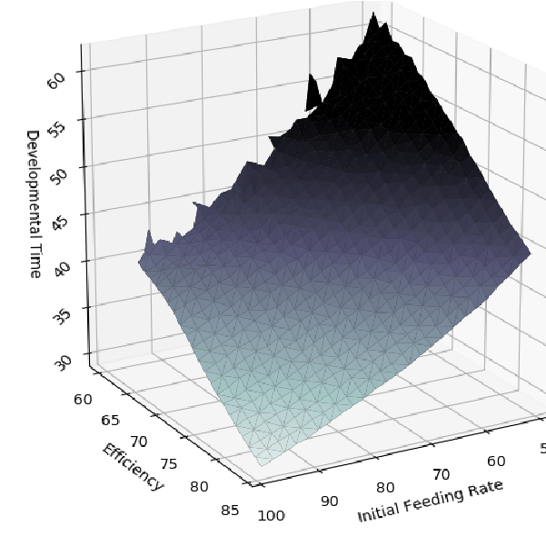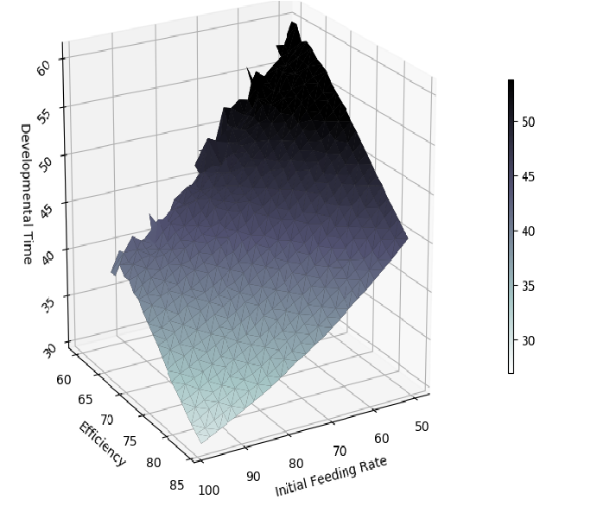

(a) MB culture (b) MCU culture (c) CCU culture

Figure 2.2: Effect of initial feeding rate and efficiency on development time

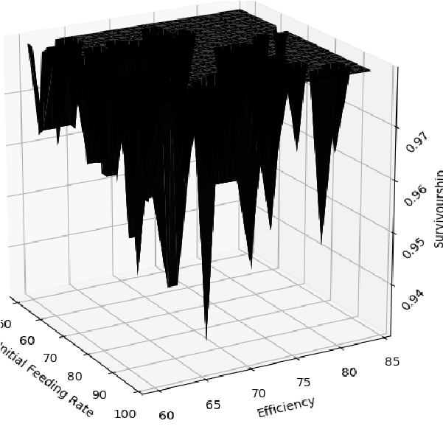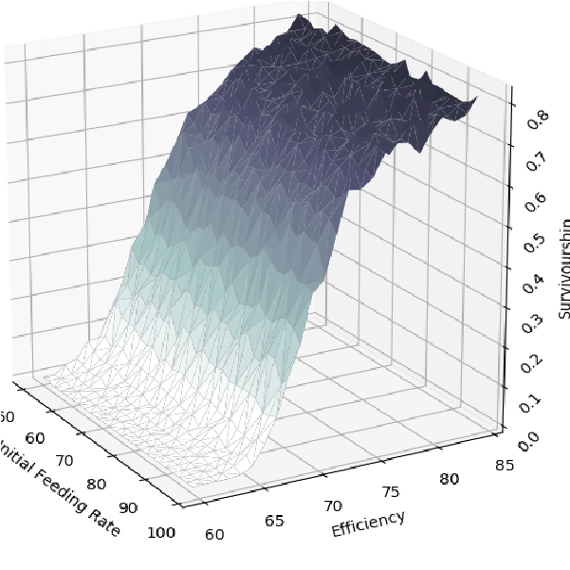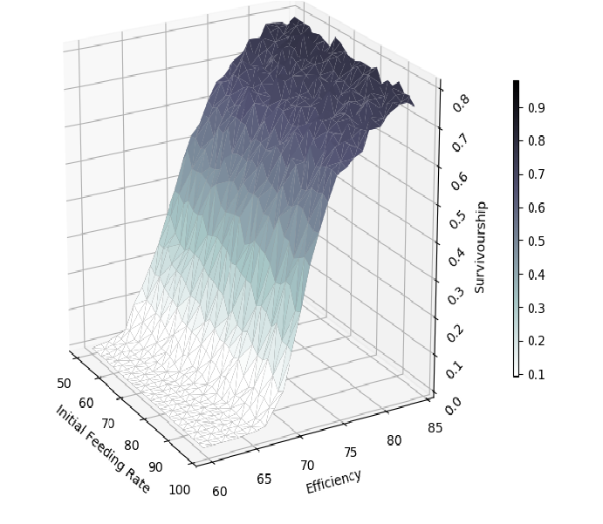

(a) MB culture (b) MCU culture (c) CCU culture

Figure 2.3: Effect of initial feeding rate and efficiency on survivorship

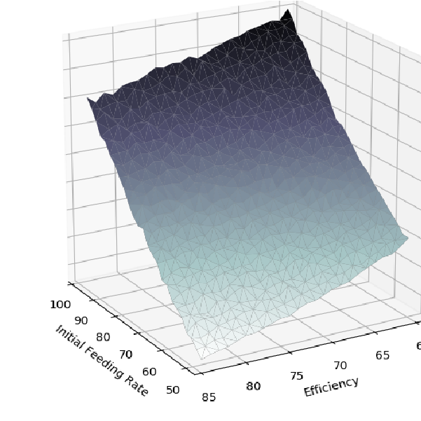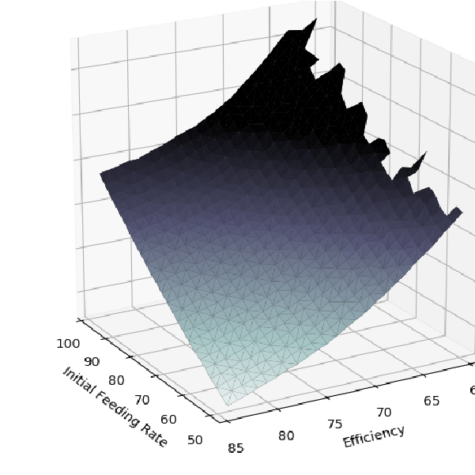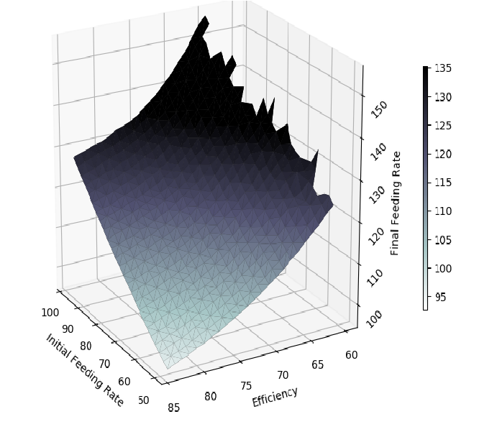

(a) MB culture (b) MCU culture (c) CCU culture

Figure 2.4: Effect of initial feeding rate and efficiency on final feeding rate

## 2.2 Initial Feeding Rate and Critical Size

For simualtions varying parameter range of mean trait values of initial feeding rate and critical size, all traits show similar pattern with varying density as seen with previous simulations. The larval body size shows similar correlations with initial feeding rate and critical size in MB and MCU culture as seen in simualtions varying initial feeding rate and efficiency (see fig 2.5). In CCU culture, body size is negatively correlated with initial feeding rate only for smaller values of critical size, but it is not affected by inital feeding rate at larger critical size values. Fig 2.6 shows a negative correlation of development time with inital feeding rate, but poitive correlation with critical size in all culture vials. survivorship is logistically dependent on critical size only in MCU and CCU culture. In MCU and CCU cultures, survivorship shows a slight negative correlation with initial feeding rate (see fig 2.7). At all larval densities, final feeding rate is positively correlated with both inital feeding rate and critical size (see fig 2.8).

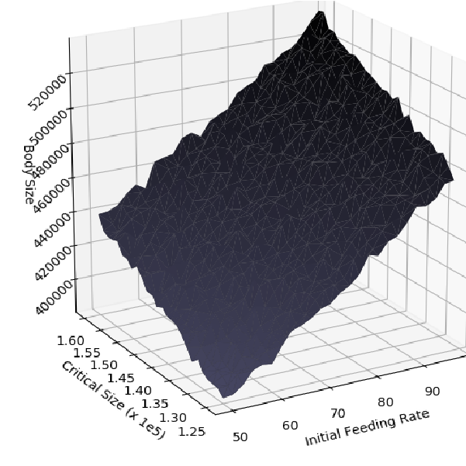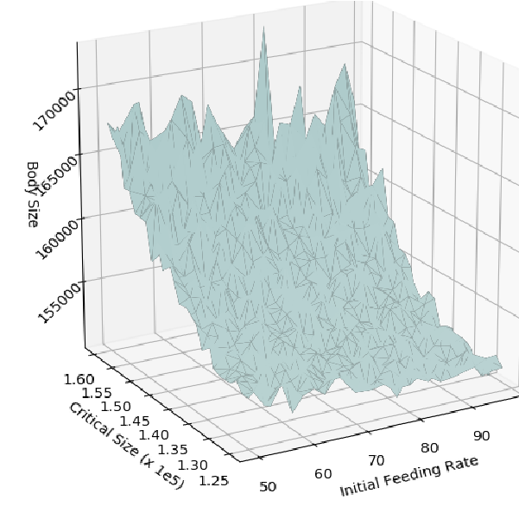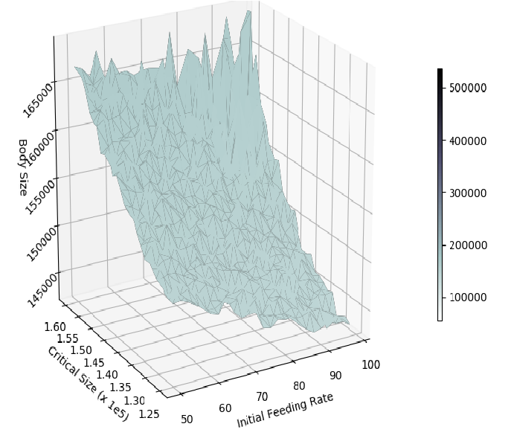

(a) MB culture (b) MCU culture (c) CCU culture

Figure 2.5: Effect of initial feeding rate and critical size on body size

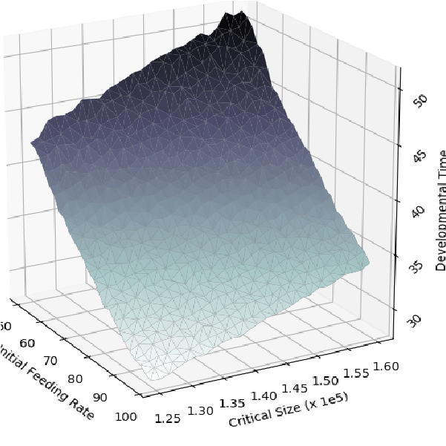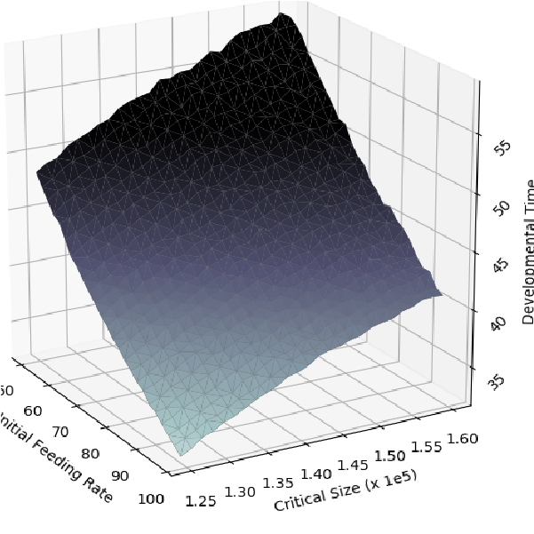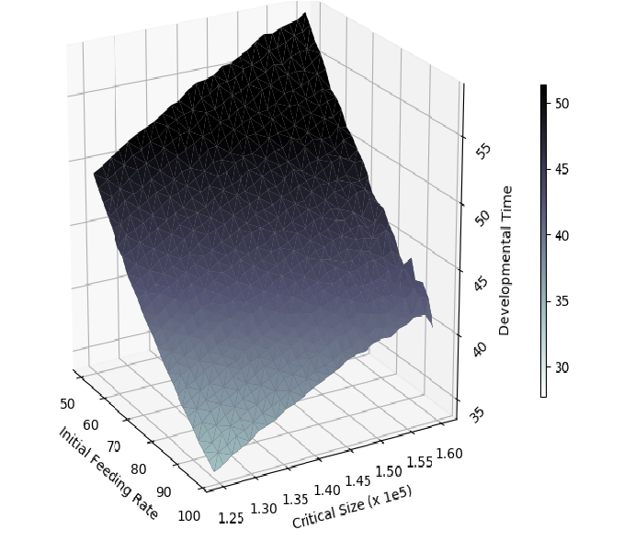

(a) MB culture (b) MCU culture (c) CCU culture

Figure 2.6: Effect of initial feeding rate and critical size on development time

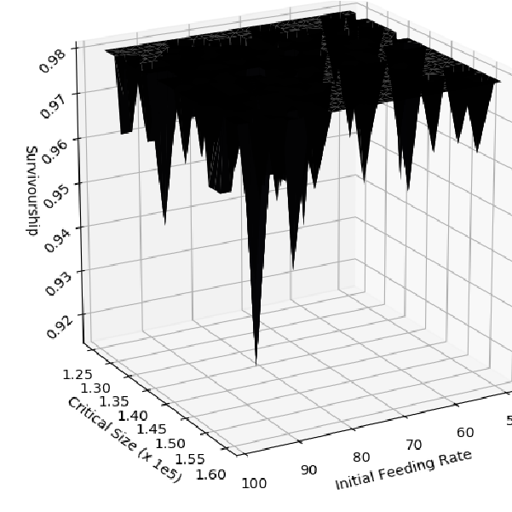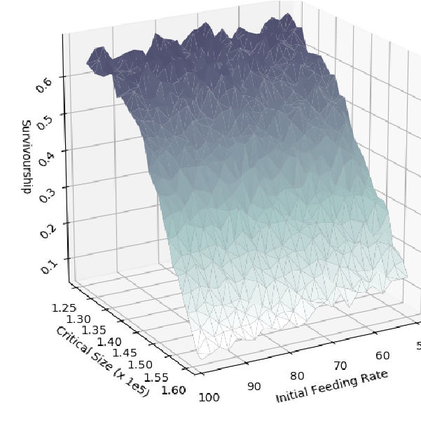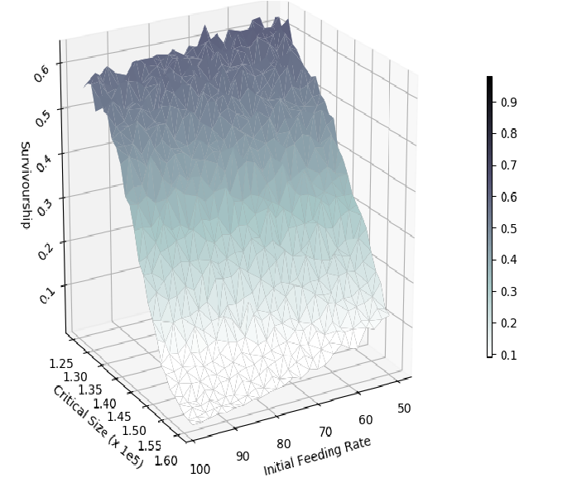

(a) MB culture (b) MCU culture (c) CCU culture

Figure 2.7: Effect of initial feeding rate and critical size on survivorship

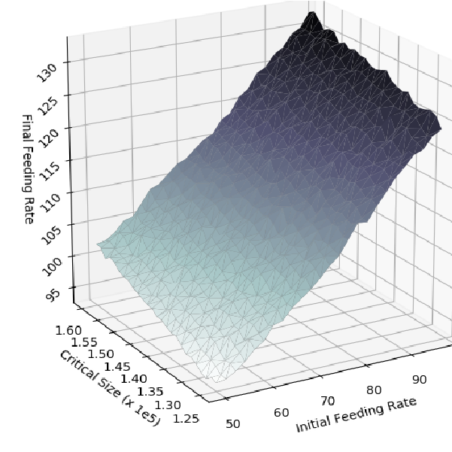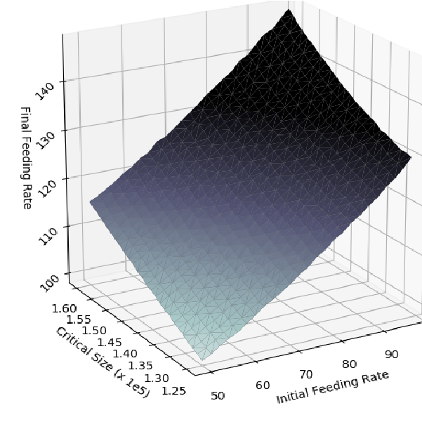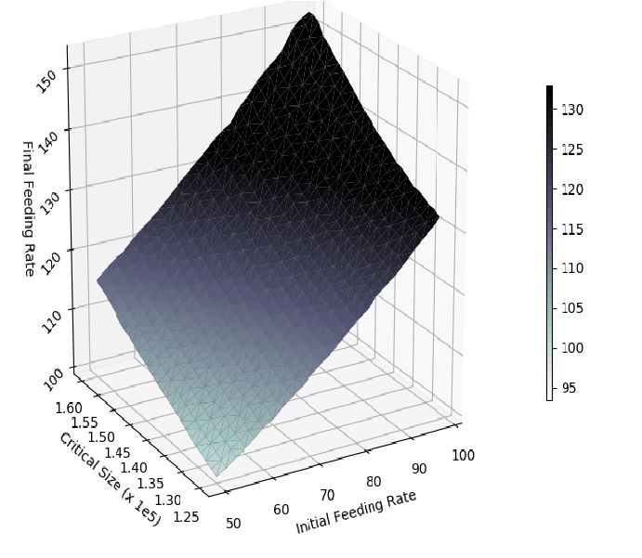

(a) MB culture (b) MCU culture (c) CCU culture

Figure 2.8: Effect of initial feeding rate and critical size on final feeding rate

## 2.3 Critical Size and Efficiency

In simualtions varying parameter range of mean trait values of initial feeding rate and critical size, all traits measured show similar pattern with varying density as seen with previous simulations. The larval body size shows similar correlations with critical size and efficiency in MB culture as seen in simualtions varying initial feeding rate and efficiency (see fig 2.9). In MCU and CCU cultures, body size is positively correlated with critical size only for smaller values of efficiency, but is not affected by critical size at larger efficiency values. Fig 2.10 shows a negative correlation of development time with efficiency, but poitive correlation with critical size at all densities. survivorship is logistically dependent on efficiency only in MCU and CCU culture. In MCU and CCU cultures, survivorship also shows a negative correlation with critical size at lower values of efficiency (see fig 2.11). At all larval densities, final feeding rate is positively correlated with critical size and negatively with efficiency (see fig 2.8).

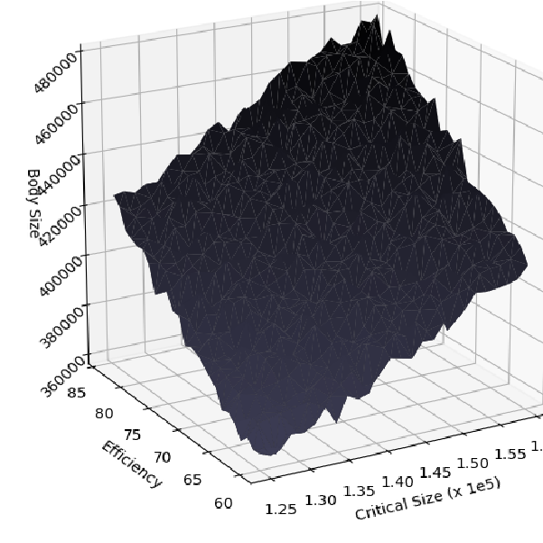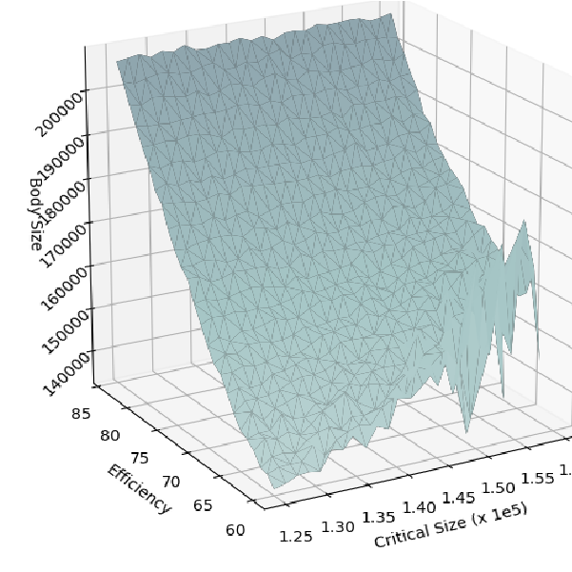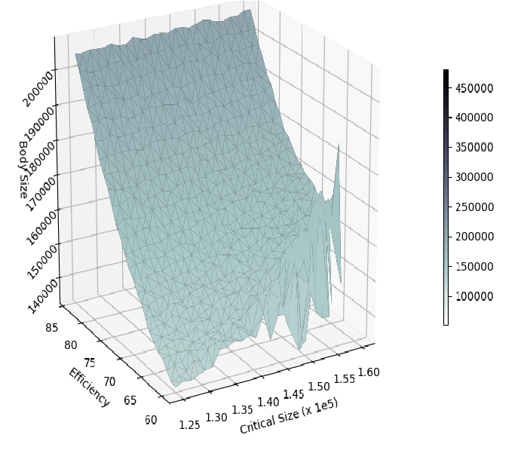

(a) MB culture (b) MCU culture (c) CCU culture

Figure 2.9: Effect of critical size and efficiency on body size

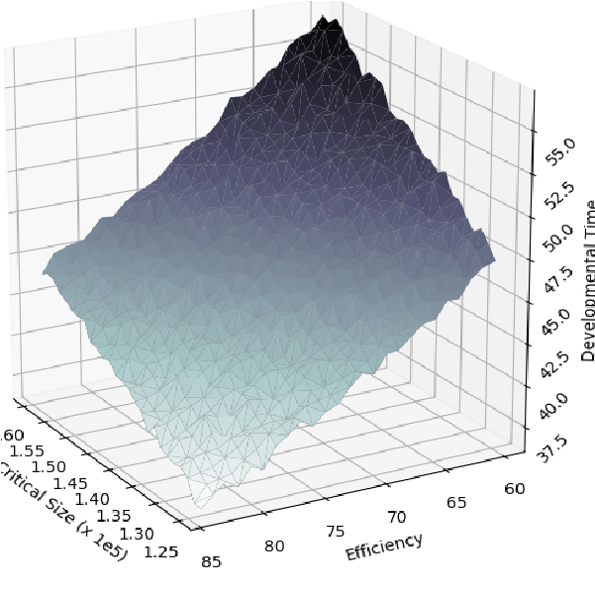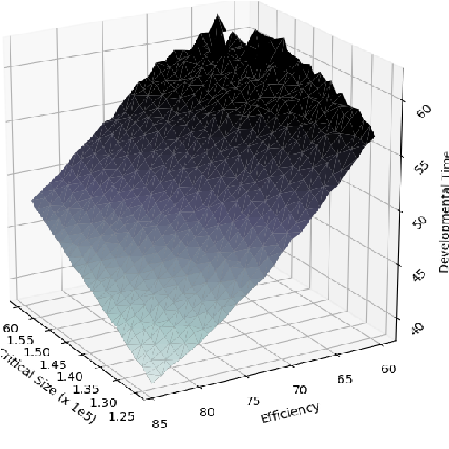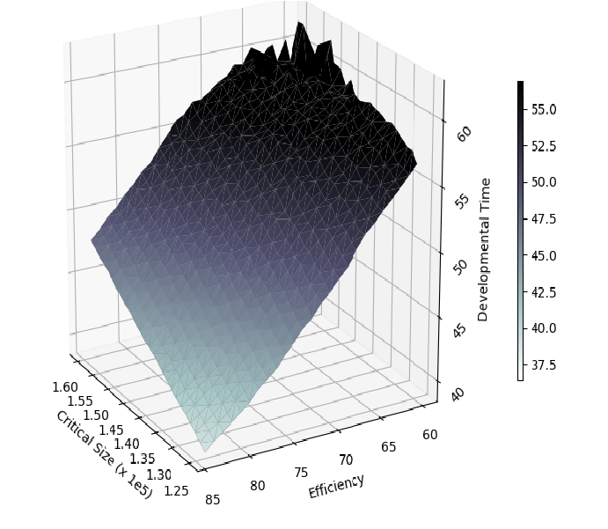

(a) MB culture (b) MCU culture (c) CCU culture

Figure 2.10: Effect of critical size and efficiency on development time

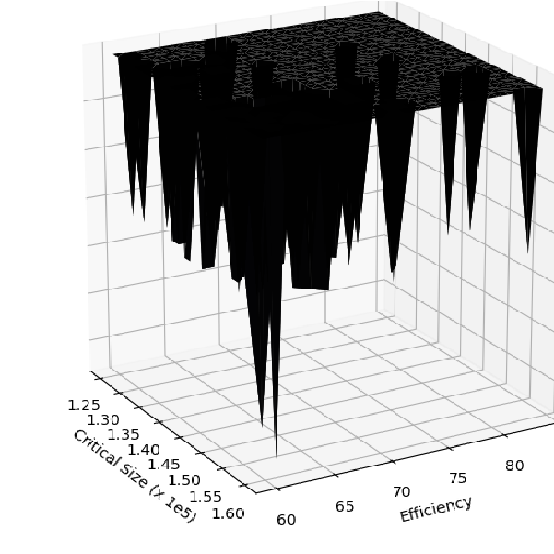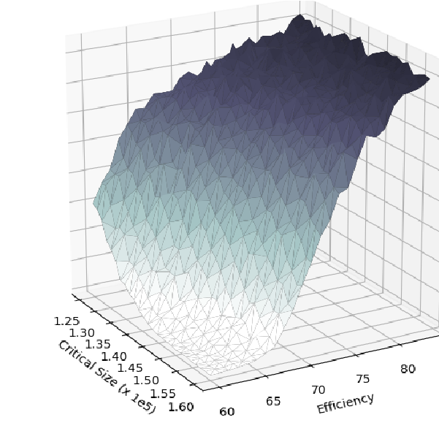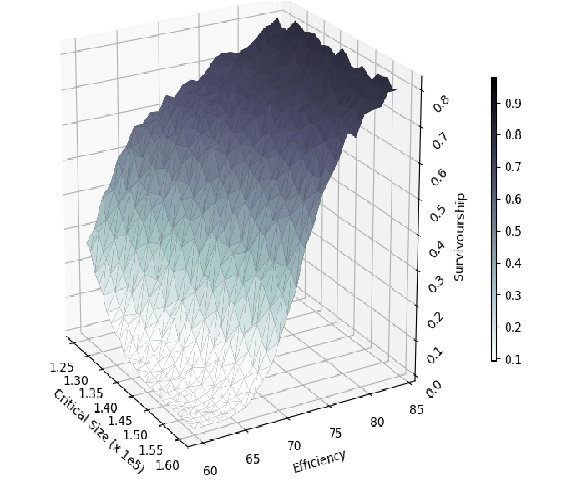

(a) MB culture (b) MCU culture (c) CCU culture

Figure 2.11: Effect of critical size and efficiency on survivorship

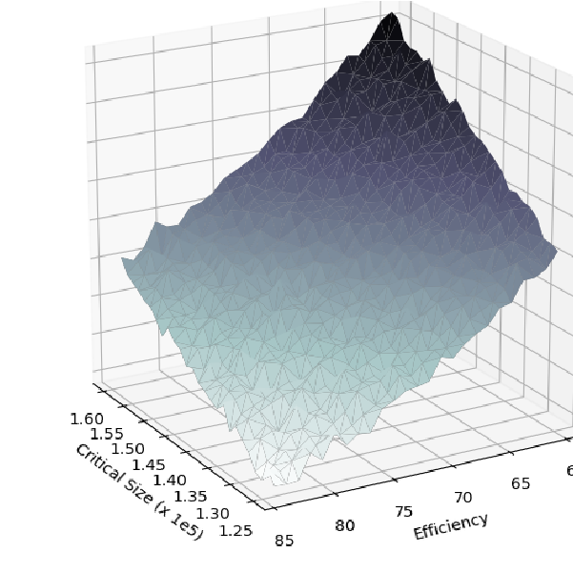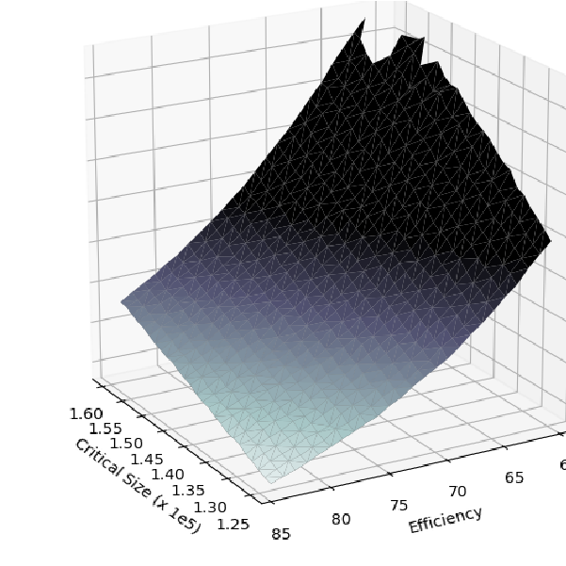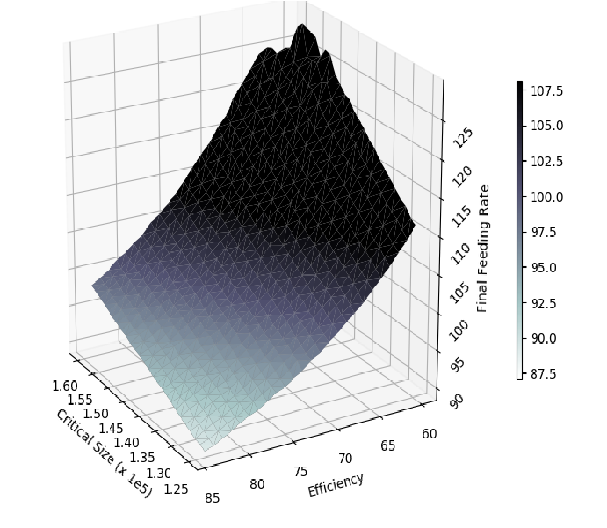

(a) MB culture (b) MCU culture (c) CCU culture

Figure 2.12: Effect of critical size and efficiency on final feeding rate

**Chapter 3**

**Modelling Evolution of Life-history**

# Traits

## 3.1 Modelling Adult Stage

After modelling larval stage and calibrating, I developed the model for the pupal and adult stage of *Drosophila* life cycle. After larval stage, surviving individuals go through pupal stage where some of them undergo pupal mortality. The adult stage includes randomly choosing surviving adults from all replicate vials of pupal stage, matings, and inheritance of larval trait parameters from parents to offspring. Female is mated once with random male chosen from the adult population (*n* = 2400) with replacement for simplicity. From all the offspring produced, eggs are chosen at random for the next generation with numbers respective to the crowding environment maintained.

### 3.1.1 Pupal stage

After collecting all the surviving individuals from the larval stage, a probability of death during pupal stage is assigned to each survived larva. This probability is dependent on the amount of waste accumulated in the body while econsuming food during the larval stage. This probability is given as:

*PM*(*i*) = 1 − *exp*(−(*Wacum*(*i*) · *x*3)2)

Here,

*PM* = Probability of dying during pupal stage

*Wacum*(*i*) = Waste accumulated by *ith* larva during larval stage *x*3 = Scaling parameter

### 3.1.2 Fecundity

After each mating, the number of eggs produced for a female are derived from the fecundity equation based on the model of (ref) Tung S. (year). Fecundity is taken as a function of body size of the female and adult nutrition parameter (the amount of yeast provided). Fecundity of an *ith* female is given as:

*Eggi* = *Nut* · *x*3 · log(*x*4 · *si*)

Here, *si* = body size of the *ith* female

*Eggi* = Number of eggs laid by the female in a mating *Nut* = Adult nutrition i.e. the amount of yeast provided *x*3*,x*4 = scaling parameters

### 3.1.3 Inheritance

Larval trait parameters (initial feeding rate, effieciency, waste tolerance and critical size) are inherited from parents to offspring produced by each female using midparent value. The mid-parent value i.e. average of mother and father for each larval parameter of all offspring is calculated. This mid-parent value is taken as a mean of a normal distribution with fixed standard deviation for respetive trait parameters. The standard deviation in this normal distribution determines the heritibility of the mid-parent value and it is considered to be different for each trait parameter. Trait parameters of the offspring are assigned as:

*Ti* ∈ *N*(*mpvT,δT*)

Here,

*Ti* = Trait parameter assigned to *ith* offspring from a mating *mpvT* = Mid-parent value of of the trait *T* for a given mating *δT* = heritability of mid-parent value of the trait *T*

*N*(*mpv,δ*) = Normal distribution with *mpv* as mean and *δ* as standard deviation

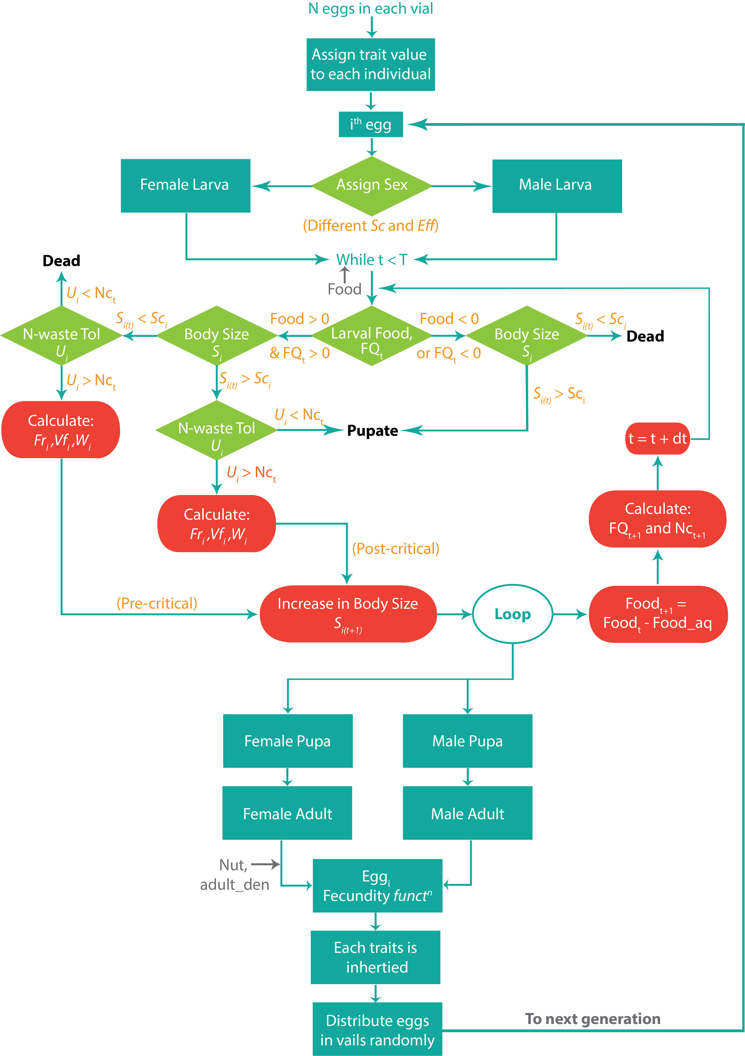

Figure 3.1: Model flowchart

## 3.2 Effect of Laral Crowding on the Evolution of Life-history Traits

Using values for all parameters given in table B.3 and table B.2, the entire model is simulated for 100 generations with 10 replicates for MB, MCU and CCU cultures. The overall model follows the path shown in fig 3.1. All larval trait parameters are taken from independent distribution and there is no correlation between them (see table B.1). To see how larval trait parameters evolve over time, timeseries for these traits of surviving adult individuals are plotted with 95% CI.

In MB culture, being control population, nonw of the parameters evolve over time (see fig 3.2, fig 3.3, fig 3.4, fig 3.5). Initial feeding rate in high density cultures increase over generations at similar rate but inital feeding rate is higher always in CCU culture always than in MCU culture. Efficiency show similar trend in high density cultures i.e. it increases over generations at similar rate but is higher always in CCU culture always than in MCU culture. Critical size in high density cultures decreases at the same rate but critical size in CCU culture is always lower than in MCU culture. Waste tolerance does not evolve in all of the culture populations since there is no significant change in waste tolerance value.

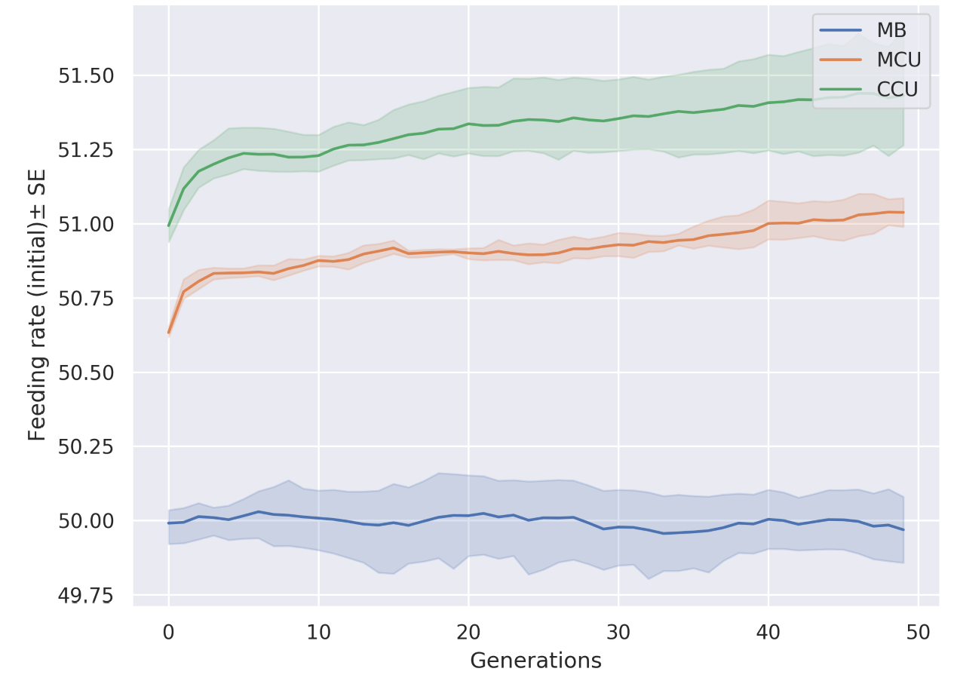

Figure 3.2: Timeseries for initial feeding rate

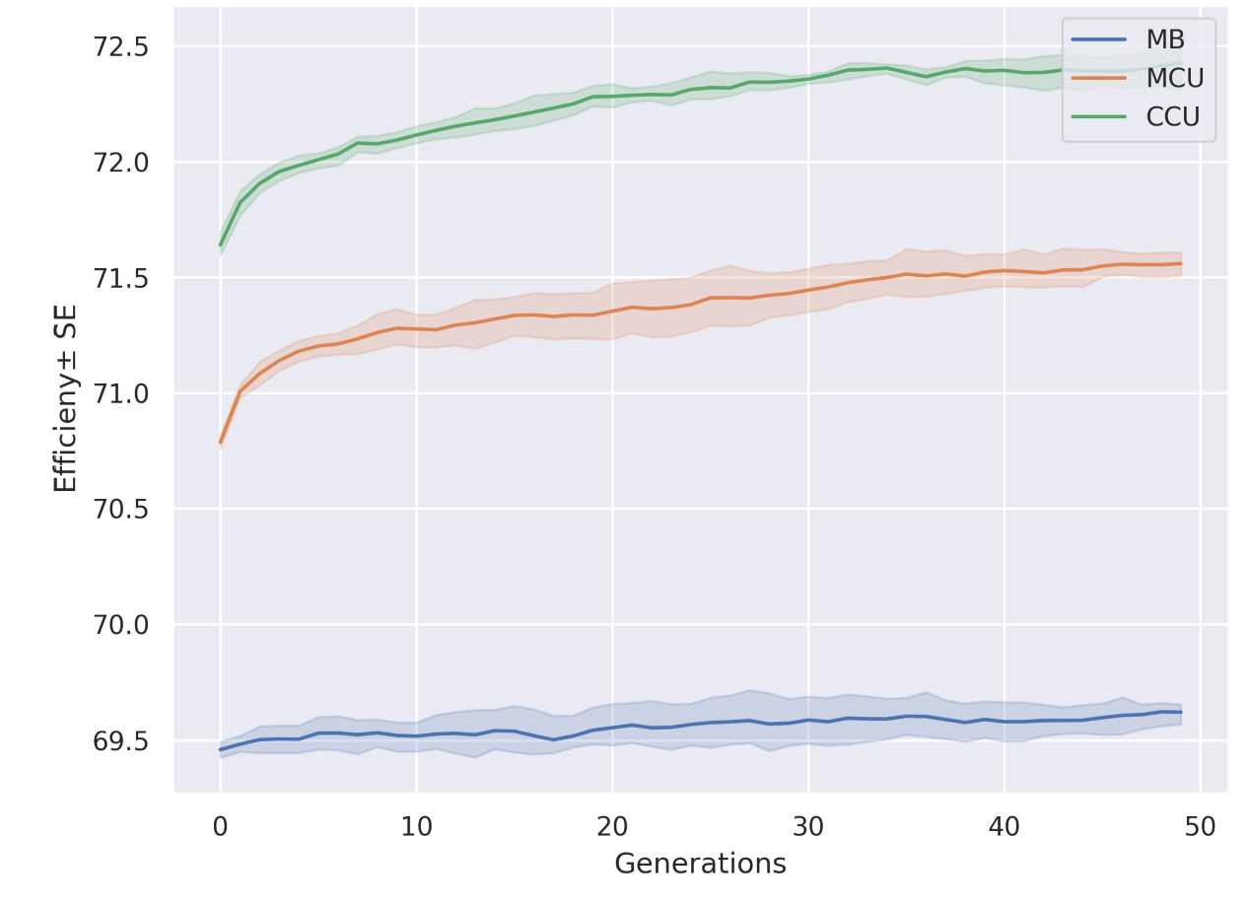

Figure 3.3: Timeseries for efficiency

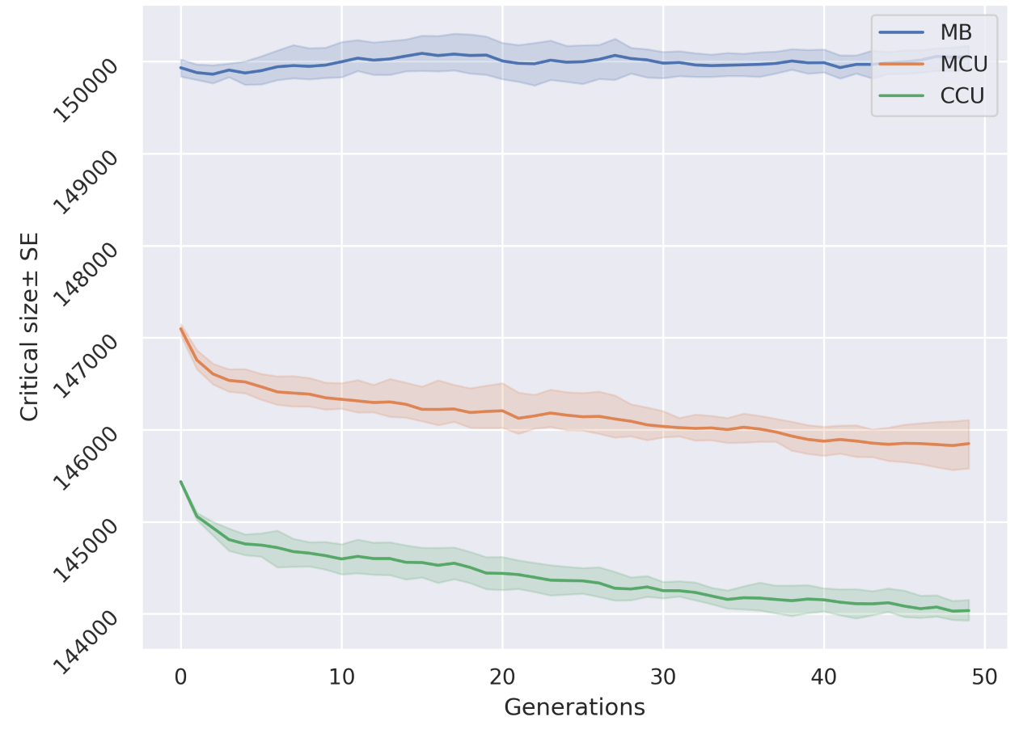

Figure 3.4: Timeseries for critical size

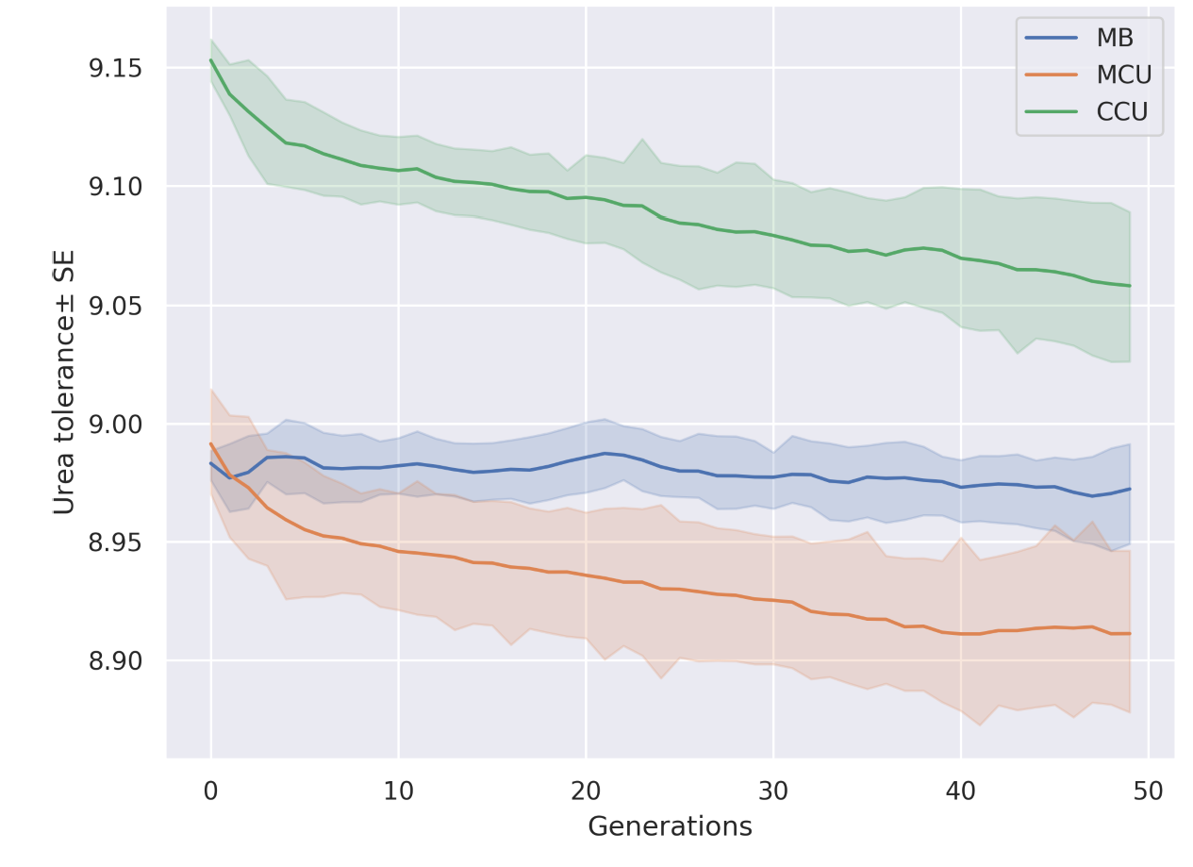

Figure 3.5: Timeseries for waste tolerance

## 3.3 Effects of Variation on the Evolution of Larval Trait Parameters

The stochasticity in the model comes from the initial variation in the larval trait parameters, given as certain variation in the respective initial distribution as well as from the heritability of the mid-parent value during the inheritance of the larval trait parameters. The simulations show how these sources of variations play an important role in determining the evolutionary routes taken to achieve greater competitive ability by having maximum survivorship.

### 3.3.1 Variation in the Initial Distribution of Larval Trait Parameters

In the initial distributions of all trait values, the variotion comes from the standard deviation given for each distribution. After 50*th* generation, the initial variation in these trait distributions determine the maximum mean trait value that can be achieved to increase the fitness. From fig 3.6 - fig 3.8, it is clear that differences in variation of these trait values, mean trait values reached are different for different combinations of intial variation in trait values.

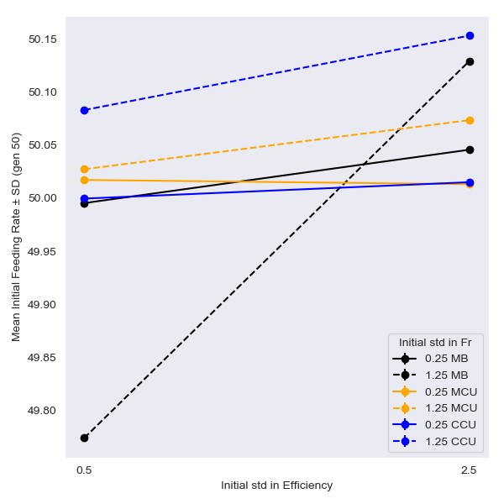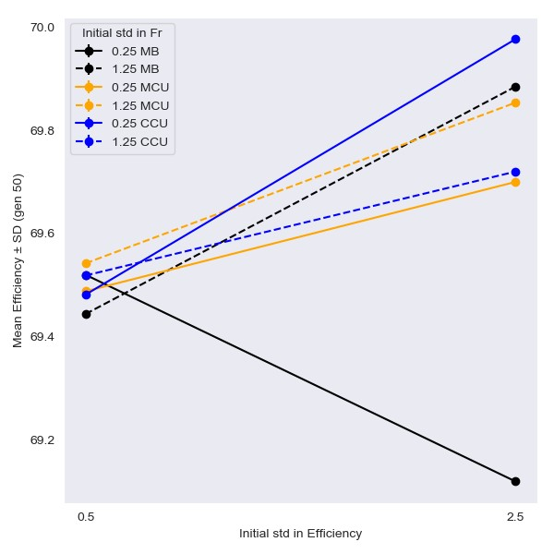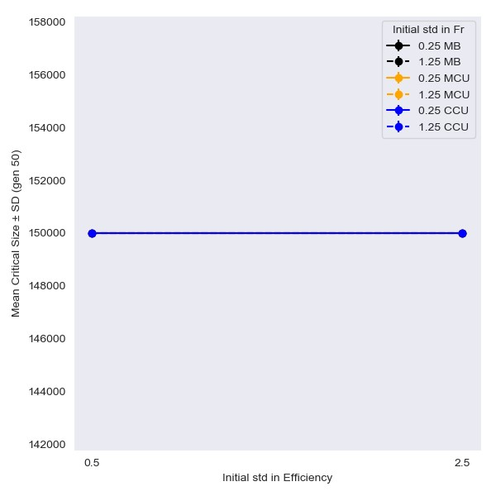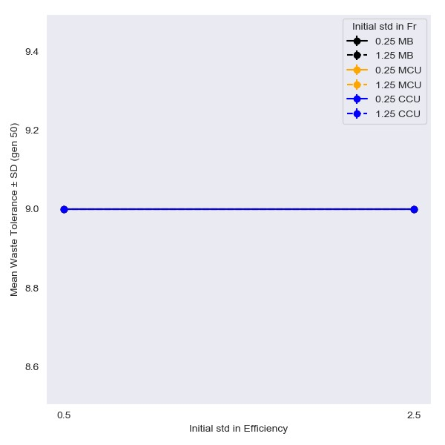

Figure 3.6: Effect of initial variation in initial feeding rate and efficiency on mean trait values at generation 50.

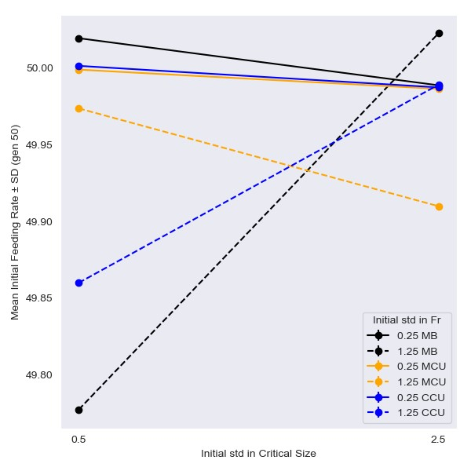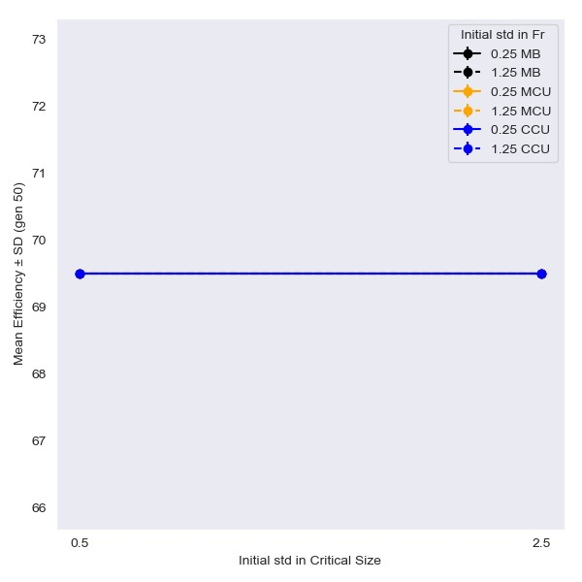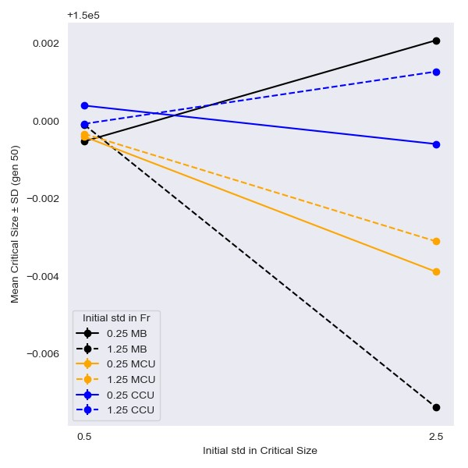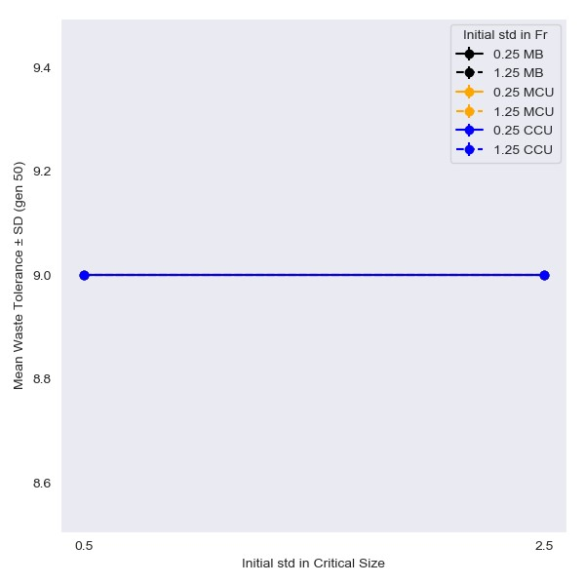

Figure 3.7: Effect of initial variation in initial feeding rate and critical size on mean trait values at generation 50.

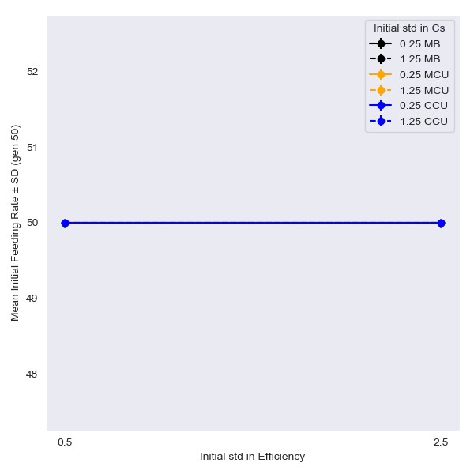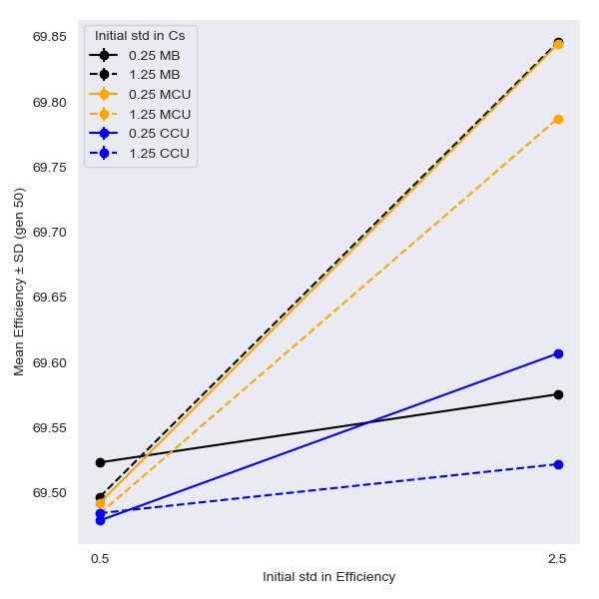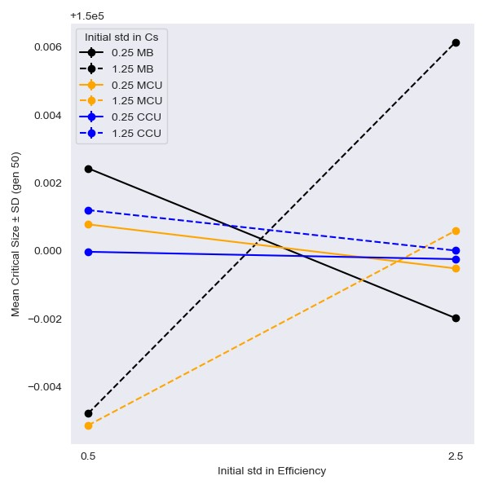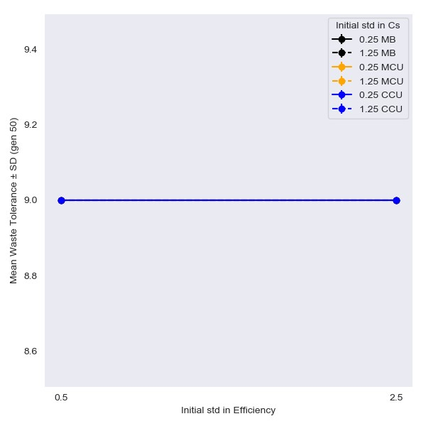

Figure 3.8: Effect of initial variation in critical size and efficiency on mean trait values at generation 50.

### 3.3.2 Heritability of Mid-parent Value

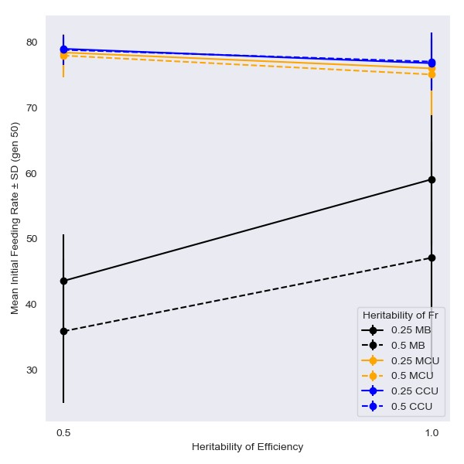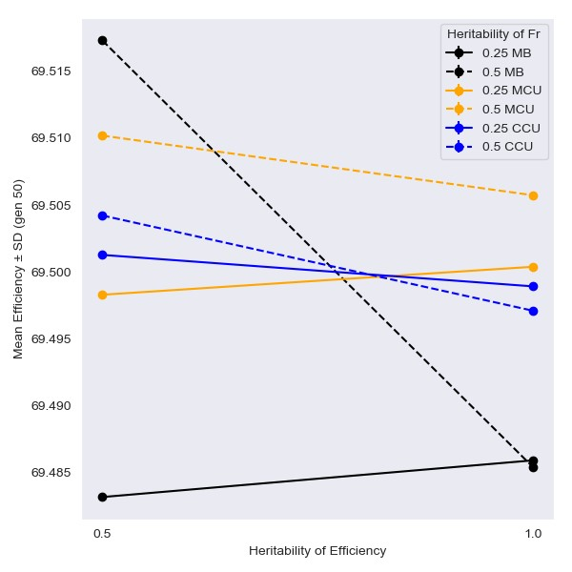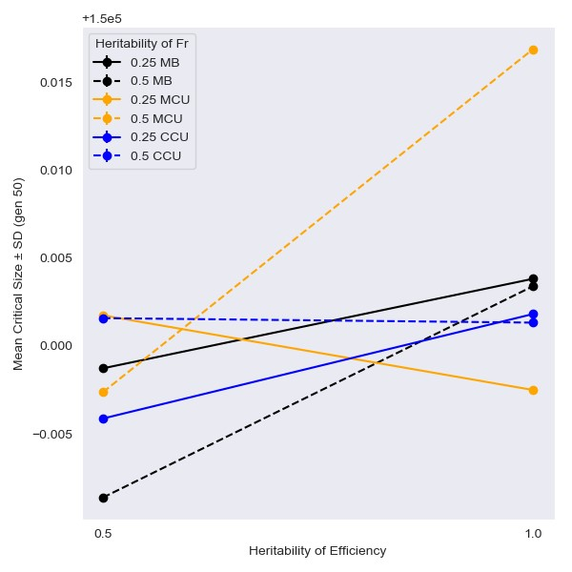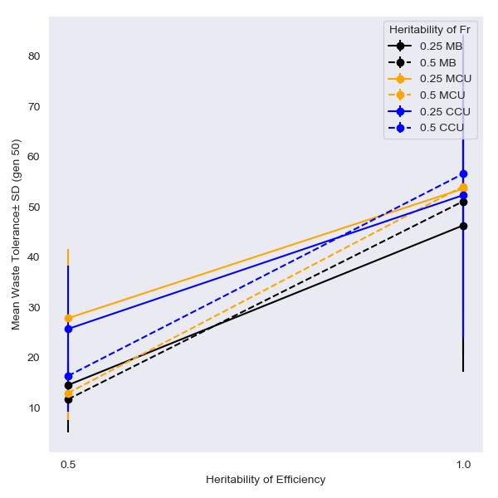

Figure 3.9: Effect of heritability in initial feeding rate and efficiency on mean trait values at generation 50.

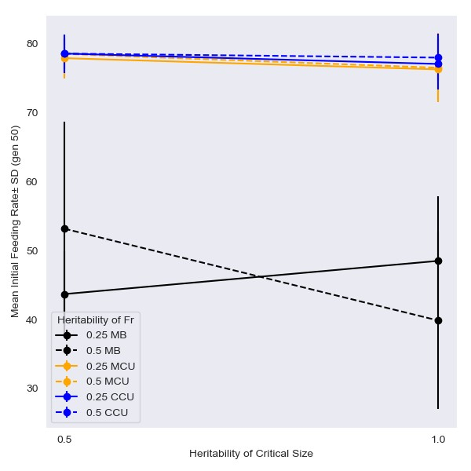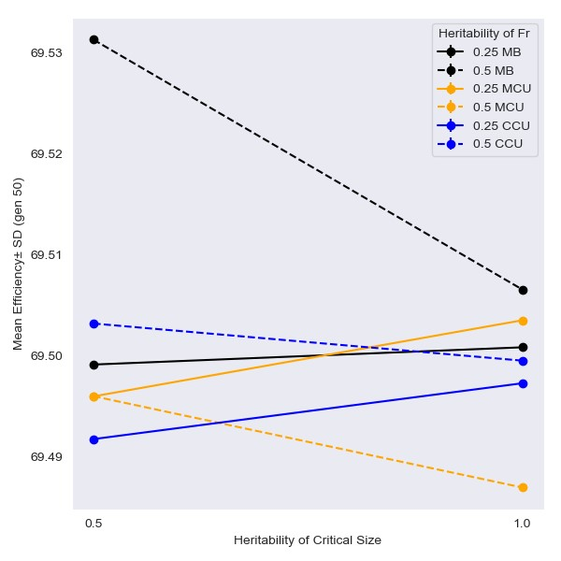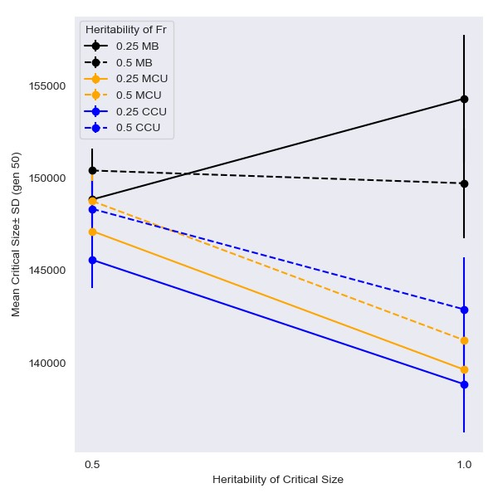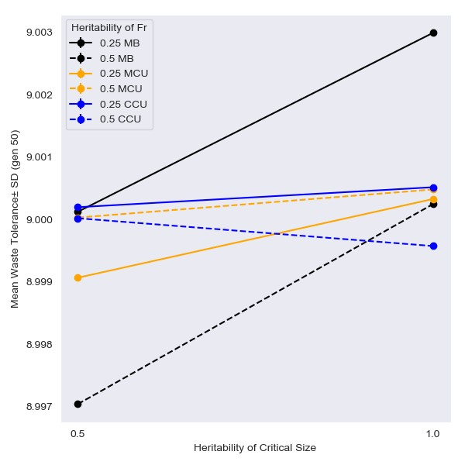

Figure 3.10: Effect of heritability in initial feeding rate and critical size on mean trait values at generation 50.

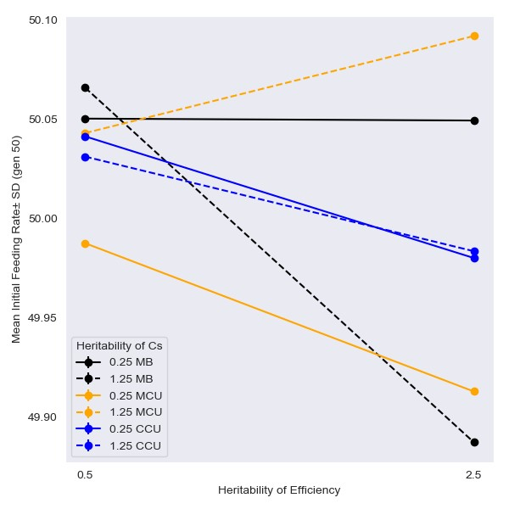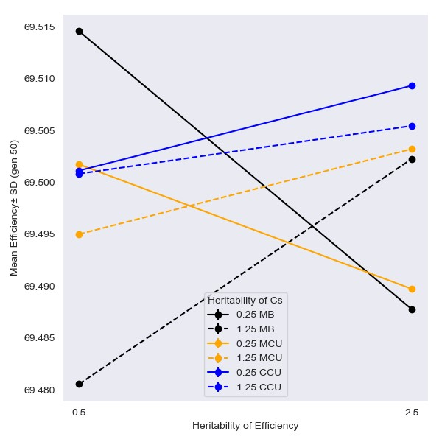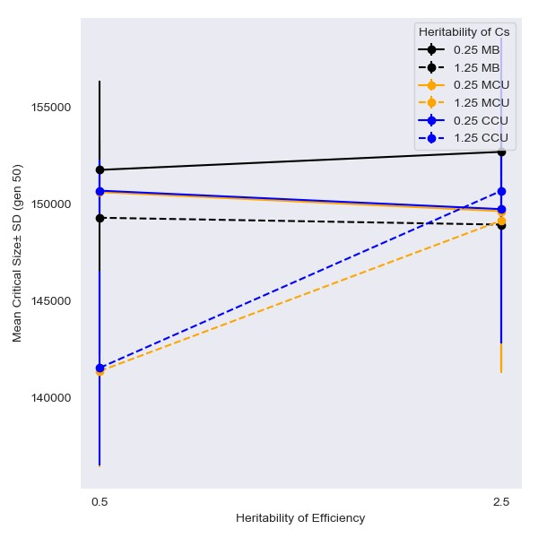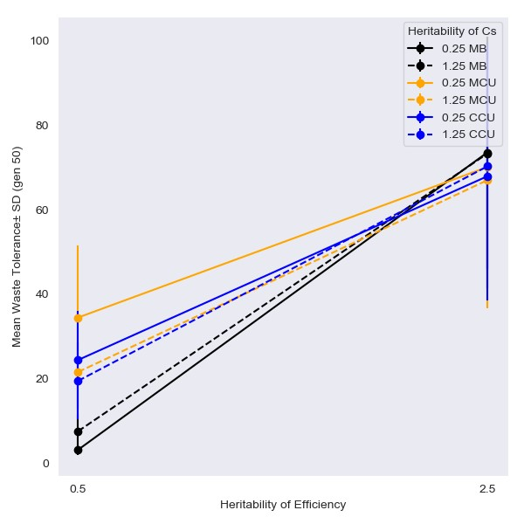

Figure 3.11: Effect of heritability in critical size and efficiency on mean trait values at generation 50.

# References

Sarangi, M. (2018). *Ecological details mediate different paths to the evolution of larval competitive ability in Drosophila* (Thesis, Jawaharlal Nehru Centre for Advanced

Scientific Research (JNCASR)). Accepted: 2019-07-26T10:33:37Z.

**Appendix A**

**Code**

**Appendix B**

# Tables

This appendix contains values of all paramters used in the simulations.

## B.1 Larval Trait Parameters

|  |  |  |  |
| --- | --- | --- | --- |
| **No.** | **Larval Trait** | **Symbol** | **Distribution** |
| 1. | Initial feeding rate |  | *N*(*,*) |
| 2. | Critical size |  | *N*(*,*) |
| 3. | Efficiency |  | *N*(*,*) |
| 4. | Waste tolerance |  | *N*(*,*) |

Table B.1: Distributions and values of larval trait parameters used for initiating the model

## B.2 Scaling Parameters

|  |  |  |
| --- | --- | --- |
| **No.** | **Paramter** | **Value** |
| 1. | *x*1 | 0.017 |
| 2. | *x*2 | 1e4 |

Table B.2: Values of scaling parameters used in the model

## B.3 Other Larval Parameters

|  |  |  |  |
| --- | --- | --- | --- |
| **No.** | **Paramter** | **Symbol** | **Value** |
| 1. | Larval food (1.5 ml) | *food* | 1.85e8 |
| 2. | Inital body size (*t*=0) | *Si*(0) | 3.0 |
| 3. | Proportion of waste diffusion | *kd* | 0.12 |
| 4. | Feeding band size | *fband* | 7.4e9 |
| 5. | Diffusion band size | *dband* | 7.4e9 |
| 6. | Volume of food (pre-cirtical) | *Vf*(*pre*) | 1.0 |

Table B.3: Values of larval parameters used for initiating the model